Numerical Modelling of Shale Oil Production Estimates in a Naturally Fractured Reservoir

Submitted by Prateek Bhardwaj

**Abstract**

Square-root-of-time plot is the most common and popular method for analyzing transient linear flow, which is the dominant flow regime observed and may continue for several years in low permeability reservoirs. A similar analysis approach is used to evaluate a proposed method for calculating Distance of Investigation (DOI) in SPE 168981. However the proposed method does not consider natural fractures in the shale reservoir. Naturally fractured reservoirs form a complex network of fractures when hydraulic fracture interacts with the natural fracture network. It is an important factor to take into consideration while estimating production, especially from a low permeability system like shale. The objective of this work is to determine whether or not the shale oil production estimate method from the paper will work for a naturally fractured reservoir. In this work, a 3D numerical model has been defined for a shale reservoir with micro fractures and a hydraulic fracture using CMG. A simple case of single phase oil reservoir with a constant FBHP is taken as the base case for carrying out the comparison. The oil production was simulated numerically for two kind of reservoir fracture systems; with only a hydraulic fracture and with natural micro fractures and hydraulic fracture. The effect of natural fractures on production estimates has been studied and compared with a model similar to that proposed in SPE 168981. The model used is essentially a single phase oil reservoir with constant FPHP production. Results presented in this work give a comparison between a naturally fractured reservoir and a simple hydraulically fractured reservoir. It is attempted to conclude whether or not the proposed method in SPE 168981 will be a good method for recovery estimates in naturally fractured shale.

**Introduction**

Natural fractures are one of the most critical factors in defining an economic or prospective shale. The resulting fracture systems from hydraulic fracturing are often complex, essentially due to intersection of the hydraulic fractures with natural fracture network. In SPE 168981, a procedure for analyzing transient linear flow is provided and current DOI estimation methods are reviewed followed by a derivation of a new method. The application of the method is then examined by application on shale oil production estimates for shale was examined using the square root of time plot. The analysis procedure determines xf√ki by using the slope of the straight line obtained by plotting inverse of oil rate verses square-root-of time. Here xf is the fracture half length of the hydraulic fracture. Then it proceeds to quantify the impact of DOI calculation on the derived values of xf√ki. The paper presents two methods for analyzing transient linear flow of gas and oil: Constant flowing bottom hole pressure production and constant surface oil and gas rate production. Different cases considered in the paper include single phase oil with constant FBHP, single phase oil with constant oil rate production, single phase gas with constant FBHP, two phase oil at bubble point pressure at constant FBHP and two phase gas condensate at constant gas rate production.

In this work, a 3D numerical model has been defined for a shale reservoir with micro fractures and a hydraulic fracture using CMG. Black-oil model and single porosity system was used and fractures were simulated as grid blocks with high permeability. A sensitivity study for matrix permeability 0.01mD, 0.001mD and 0.0001mD has been done to examine the effect of natural fractures on production estimates under varying matrix permeability. The method used in this work corresponds to the constant flowing bottom-hole pressure.

**Methodology**

There are a couple of methods proposed in the given paper but the constant FBHP method is simulated. This method proposed in SPE 168981 considers a single phase oil reservoir in a stress sensitive formation for the constant FBHP well-constraint. The formation volume factor, rock porosity and permeability and oil viscosity are pressure dependent parameters. The inverse of oil rate is plotted against square-root of time in Cartesian coordinates and data should follow a straight line.

It is important to note that our simulation considers rock permeability and porosity as constant values in the grid and the values of viscosity and FVF are generated by the inbuilt PVT model in CMG. However the results obtained follow a similar trend with the method used in the paper with the inverse of production varying with square root of time almost linearly. Another source difference between the simulation and the analytical results in the paper can be the relative permeability data used. A 90% initial oil saturation is assumed and typical values residual water saturation and Corey type functions are used to model relative permeability values.

Rock and Fluid Properties used for reservoir simulation:

|  |  |
| --- | --- |
| **Property** | **Value** |
| Rock Compressibility | 6.8 E-06 psi-1 |
| Reservoir Permeability | 0.01mD, 0.001mD, 0.0001mD |
| Reservoir Porosity | 0.06 |
| Initial Reservoir Pressure | 5000 psi |
| FBHP | 1000 psi |
| Reservoir thickness | 100 ft. |
| Bubble Point Pressure | 900 psi |
| Oil Density | 35 API |
| Reservoir Temperature | 158oF |
| Half-length of Hydraulic Fracture | 250 ft. |
| Hyd. Fracture width | * 1. ft. |
| Microfracture width | 0.05 ft. |
| Natural microfracture permeability | 10 md |
| Hydraulic Fracture permeability | 1000 D |

The simulation model used for production estimates is described in Figure 1. Pressure in the field was captured at the same time during the simulation runs (2001-06-04) to visualize the effect of natural fracture network on the pressure. A sensitivity study of varying matrix permeability is carried out for k=0.01mD, 0.001mD and 0.0001mD. The fractures are assumed to be high permeability zones with a porosity of 0.99, assuming no effect of proppant since the paper considers fractures as zones of infinite conductivity. Also, the pressure profiles in the naturally fractured reservoir can be clearly observed in contrast with just a hydraulically fractured reservoir. These pressure profiles also serve as a method to validate the model being used for simulation. The pressure in the reservoir has been captured on the same date for the purpose of comparison between the different cases. **(Figures 2, 3, 4).**

***500 ft.***

***Producer Well 1***

***Hydraulic Fracture***

***250 ft.***

***120 ft.***

***120 ft.***

***120 ft.***

***120 ft.***

***500 ft.***

**Figure 1 : Base Reservoir Geometry for naturally fractured reservoirs**

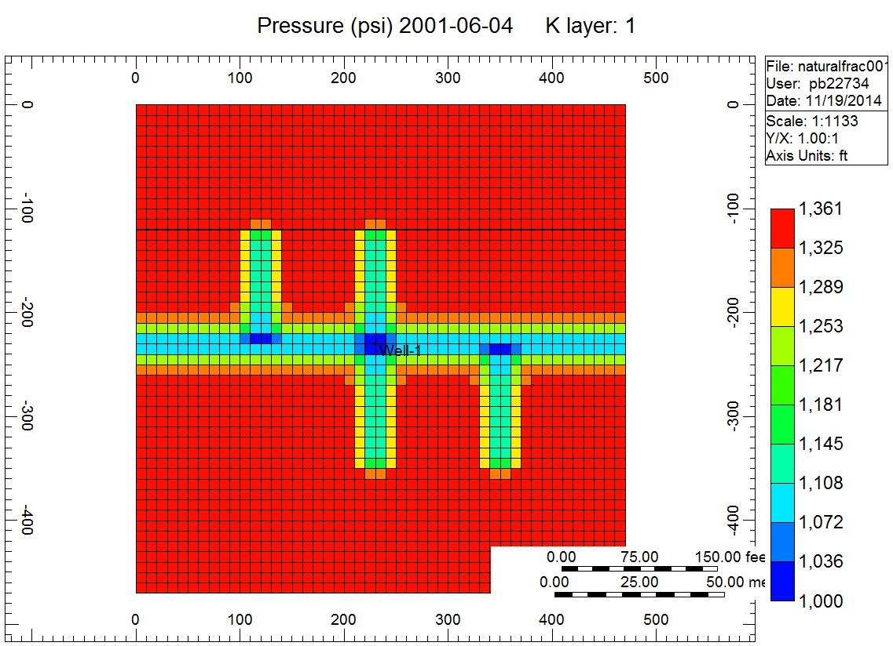

**Figure 2 Matrix K=0.0001mD (With microfractures)**

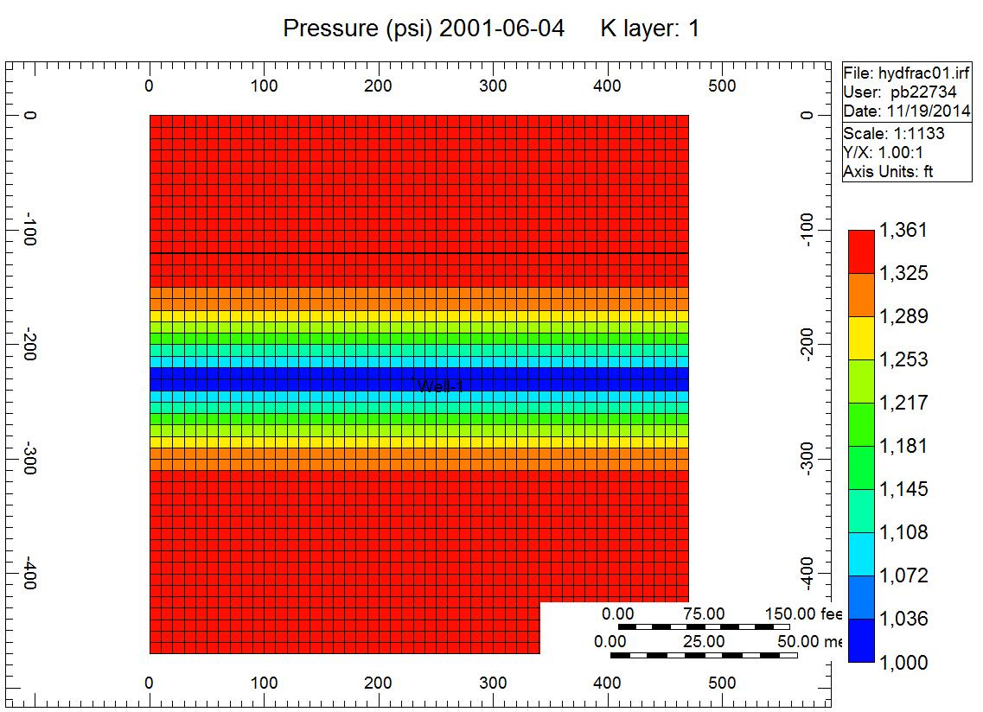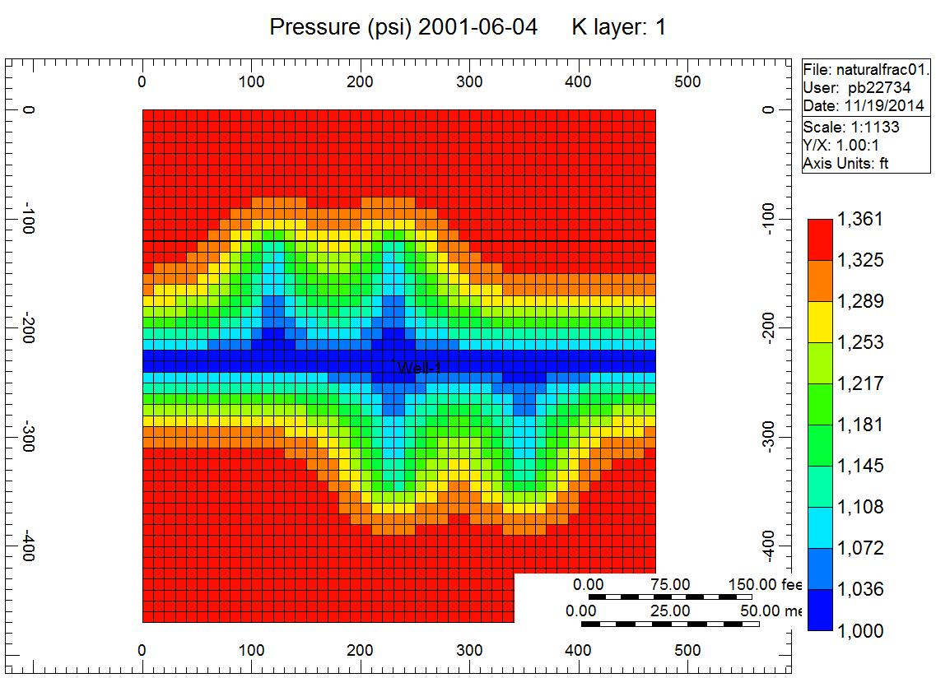

**Figure 3: Matrix K=0.001mD a) Only Hydraulic Fracture b) With microfractures**

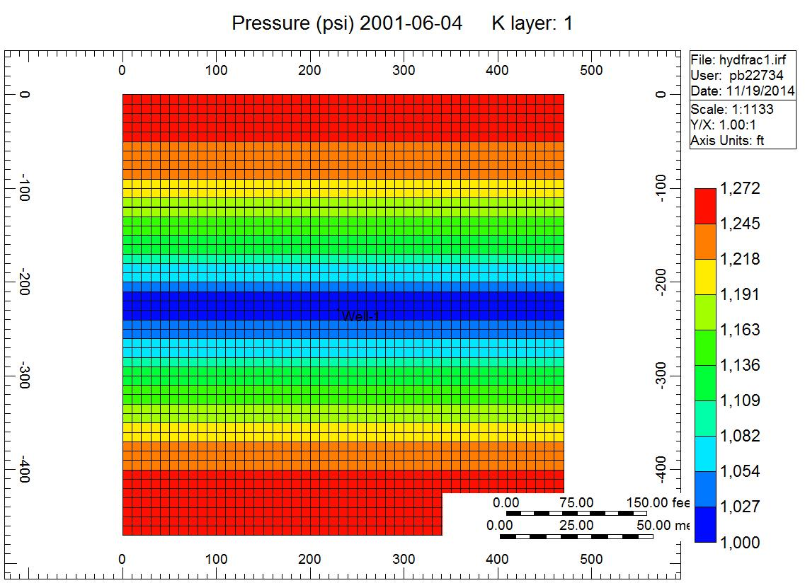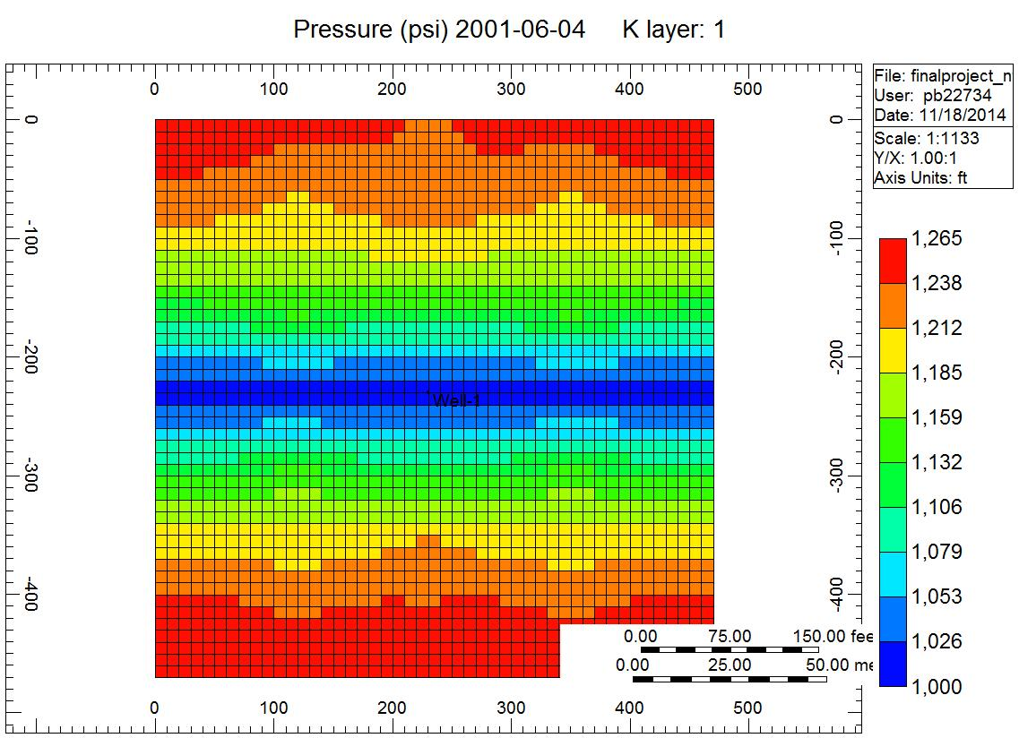

**Figure 4: Matrix K=0.01mD a) Only Hydraulic Fracture b) With microfractures**

**Results**

**Figure 5: k=0.01mD**

**Figure 6: k=0.001mD**

**Figure 7: k=0.0001mD**

**Figure 8: Comparison of Microfractured reservoirs**

**Conclusion**

In shale reservoirs, complex network structures in multiple planes are created by hydraulic fracturing. When these interact with natural fractures, the concept of single-fracture half-length and conductivity are insufficient to describe stimulation performance. In SPE 168981, it is assumed that there is no substantial reservoir fluid contribution from beyond the stimulated reservoir volume and also an assumption of pure linear flow during transient regime. Thus introducing a system of interacting micro fractures largely affects this method’s correctness for production estimates in naturally fractured shale.

In the method used in SPE 168981, the governing flow equation is linearized using appropriately defined pseudo pressure and pseudo time functions. The pseudo time concept application is dependent on linearity of the plot. The amount of error increases with increasing nonlinearity occurring through increase in permeability modulus. Shale oil production estimates for fractured reservoirs using this method can roughly provide results if an effective permeability value is correctly determined for the interaction between matrix and fractures since the plot results in a straight line after some initial time. Hence this slope (mcp) can be used to determinexf√ki.

For two phase reservoirs using this method of linearizing the diffusivity equation using pseudo pressure and pseudo time produces an error of up to 65% if the given correction factor is not applied(SPE 168981). Also, it is observed that as matrix permeability is reduced from 0.01mD to 0.0001mD, the contribution from natural fractures increases significantly, which can be seen in **Figures 5, 6, 7**. It can be concluded that in a low permeability system the effect of natural fractures increases significantly and hence the effective permeability of the reservoir system becomes a critical factor in determining the efficiency of this method for single phase oil flow.

**References**

**SPE 168981 - Modification of the Transient Linear Flow Distance of Investigation Calculation for Use in Hydraulic Fracture Property Determination** ,[H. Behmanesh](https://www.onepetro.org/search?q=dc_creator%3A%28%22Behmanesh%2C+H.%22%29) [(University of Calgary)](https://www.onepetro.org/search?q=affiliation%3A%28%22University+of+Calgary%22%29) | [S.H. Tabatabaie](https://www.onepetro.org/search?q=dc_creator%3A%28%22Tabatabaie%2C+S.H.%22%29) [(University of Calgary)](https://www.onepetro.org/search?q=affiliation%3A%28%22University+of+Calgary%22%29)| [M. Heidari Sureshjani](https://www.onepetro.org/search?q=dc_creator%3A%28%22Heidari+Sureshjani%2C+M.%22%29) [(IOR Research Institute)](https://www.onepetro.org/search?q=affiliation%3A%28%22IOR+Research+Institute%22%29) | [C.R. Clarkson](https://www.onepetro.org/search?q=dc_creator%3A%28%22Clarkson%2C+C.R.%22%29) [(University of Calgary)](https://www.onepetro.org/search?q=affiliation%3A%28%22University+of+Calgary%22%29)

**SPE167185** -**Pseudotime Calculation in Low Permeability Gas Reservoirs** S. Hamed Tabatabaie, University of Calgary, Louis Mattar and Mehran Pooladi-Darvish, IHS Fekete Reservoir Solutions